Notes on History of CO₂ Prophet: June 28, 2006

CO₂ flood prediction software, CO₂ Prophet, was developed by Texaco Exploration and Production Technology Department, as part of the U.S. DOE Class I cost shared project "Post Waterflood, CO₂ Flood in a Light Oil, Fluvial Dominated Deltaic Reservoir" under U.S. DOE Contract. DE-FC22-93BC14960. CO₂ Prophet was originally written as a Fortran program to operate under Microsoft DOS with a minimum requirement of running on an 8-bit 80386/80387 PC’s with 4 Mbytes RAM. The original compiler used proprietary graphics calls from the FORTRAN code in order to do CGA graphics. The program was updated to run on Windows 97 and NT and was distributed by U.S. DOE until early 2006. Many users of Microsoft Windows 2000 and XP operating systems encountered problems. Some of the FORTRAN code and the proprietary graphics calls were not supported in more recent Windows operating systems. The program has been patched and recompiled by Dr. S. M. (Sam) Avasthi, Avasthi & Associates, to run on 32-bit PC’s operating Microsoft Windows XP. Dr. Avasthi has generously donated the recompiled version. Avasthi’s edition fixed a lot of problems, but not the custom pattern stream lines – a minor and rarely used feature of the original CO₂ Prophet program. Most people will run CO₂ Prophet using one of the pre-set patterns such as 5-spot, 7-spot or line drive in which case the streamline plotting graphics would not even be activated. Avasthi’s edition has been checked by Donald Remson (see below) on a 32-bit PC running Windows XP Professional as the operating system. Avasthi’s edition has been checked and will run on Windows 98 second edition, NT and 2000 operating systems. Operation on Windows Vista operating system (anticipated for 2007) or 64-bit computers has not been evaluated. The U.S. DOE does not provide technical support for CO₂ Prophet.

This program is often used in conjunction with the Kinder Morgan’s CO₂ scoping models (Microsoft Excel spreadsheet) to obtain a first pass on viability of CO₂ flooding. Additional refinement and modeling with more sophisticated geological, process and economic models are required to better define a reservoir’s potential for CO₂ flooding. The model is available at http://www.kindermorgan.com/business/co2/

Review of Avasthi & Associates Version of CO₂ Prophet for XP Operating System by Don Remson May 17, 2006

Introduction:

A version of CO₂ Prophet compiled by Avasthi & Associates was evaluated in preparation for distribution by DOE. This software is intended to fulfill a demand for a version of the CO₂ Prophet model capable of executing on the currently (2006) popular Microsoft XP Operating System. The testing and evaluation of the model consisted of several steps which were all performed on a computer running XP. The evaluation involved creating a pair of sample data sets to be distributed along with the software as examples. One sample is a waterflood of a 40-acre, 5-spot pattern, and the other sample is a CO₂ flood of the same pattern. A series of runs were performed in which variables in the sample cases were changed through the user interface. Input and output files were analyzed to make sure that the changes made through the interface were implemented both in the input file generated for execution by the program and in the program execution itself. Finally, a series of sensitivity analyses were performed on several major variables which are read in as part of the model’s input. These sensitivity runs were designed as a means to make sure that the model ran correctly and also as a means of determining the user friendliness of the model. This report talks about the procedure used to test the model, and then displays some of the results generated by running the two sample datasets. Also displayed are results of sensitivity analysis performed on Dykstra Parson’s coefficient, oil viscosity, API gravity, pattern configuration, and reservoir pressure.

Procedure:

The following procedure was used to perform this analysis:

- A sample waterflood case for a single 40-acre, 5-spot pattern was generated and saved as file 40AC_wf.sav. This sample case will be distributed with the software so that it can be loaded through the interface and used as a sample case for users learning how to run the model.

- The sample waterflood case 40AC_wf.sav was modified in order to begin CO₂ injection after a hydrocarbon pore volume of water was injected. This case was then saved as 40AC_CO2.sav. This file will also be distributed with the software to provide a sample of a CO₂ flood.

- Using the user interface, most of the data elements were slightly modified one at a time and the model executed each time through the interface. At the completion of the run, the input file INDATA was checked to make sure that the appropriate variable was modified by the interface. The output file LABELOUT was then checked to make sure that the modified variable was acted on by the program.

- The sample CO₂ flood case was re-created using the custom pattern option in place of the normal pre-set 5-spot pattern. In this case, the pattern is described by providing the coordinates in feet, and the streamtubes are actually generated by the model instead of using pre-set streamtubes. The custom pattern run resulted in a close match with the pre-set pattern run.

- A series of sensitivity analyses were generated in which the effects of Dykstra Parson’s coefficient, oil viscosity, API gravity, pattern configuration, and reservoir pressure on CO₂ flood performance were reported.

Sample Waterflood Case:

A sample waterflood input file was generated to serve as an example for people learning to run CO₂ Prophet. The sample problem was designed so that many of the data values are the actual model defaults. Some of the data values for this case (40AC_wf.sav) are as follows.

Number of Model Layers = 5
Dykstra Parson’s Coefficient = 0.70
Reservoir Temperature = 105 degrees F
Average Reservoir Pressure = 2000 psia
Minimum Miscibility Pressure = 1200 psia
Oil Formation Volume Factor = 1.4 RB/STB
Solution Gas-Oil Ratio = 500 scf/stb
Oil Gravity = 30 degrees API
Gas Specific Gravity = 0.7 (air = 1)
Water Viscosity = 0.8 cp
Water Salinity = 100,000 ppm
Area = 40 acres
Net Pay Thickness = 10 feet
Porosity = 0.20 (fraction)
Current Oil Saturation = 0.70 (fraction)
Residual Oil Saturation to Water = 0.37 (fraction)
Connate Water Saturation = 0.20 (fraction)
Injection rate = 500 bbl/day of water until 2.0 pore volumes have been injected

Results of this run in terms of cumulative water injection and cumulative oil production are displayed as Figure 1.

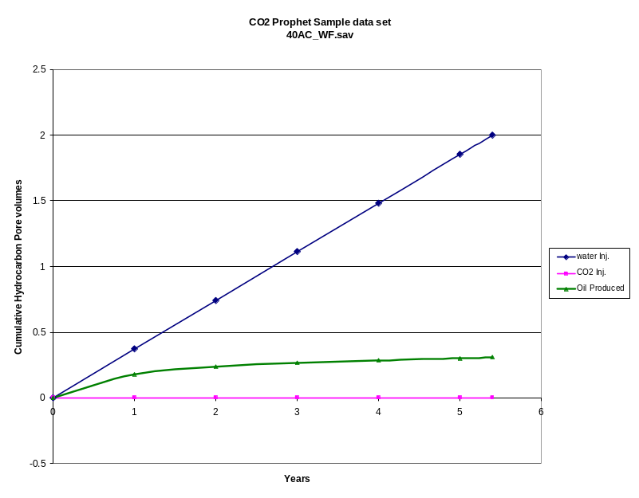
Figure 1. Sample 40-acre, 5-spot pattern waterflood

As seen in Figure 1, water injection at a constant rate of 500 bbl/day into a 40-acre, 5-spot pattern results in an oil recovery of approximately 0.3 hydrocarbon pore volumes of oil, or about 106.4 Mbbls of oil over a 5.4 year period.

Sample CO₂ Flood Case:

A sample CO₂ flood input file was generated to serve as an additional example for people learning to run CO₂ Prophet. The sample problem was derived from the 40-acre, 5-spot water flood described above. The only difference in the two sample cases is in the injection schedule. The injection schedule for the sample case 40AC_CO2.sav is as follows:

CO₂ flood injection schedule:
Waterflood - 1 HCPV at 500 bbls/day
CO2 flood - 0.2 HCPV at 1 MMSCF/day
CO2 WAG - Equal time periods of 500 bbls/day water and 1 MMSCF/day CO₂
For 0.2 HCPV of CO₂
Waterflood – 0.4 HCPV at 500 bbls/day.

Figure 2 shows cumulative water injection, CO₂ injection, and oil production for the CO₂ sample case. Figure 3 compares cumulative oil production for the waterflood case vs. the CO₂ flood case. The CO₂ flood results in an incremental 48.2 Mbbls of oil production over the waterflood case.

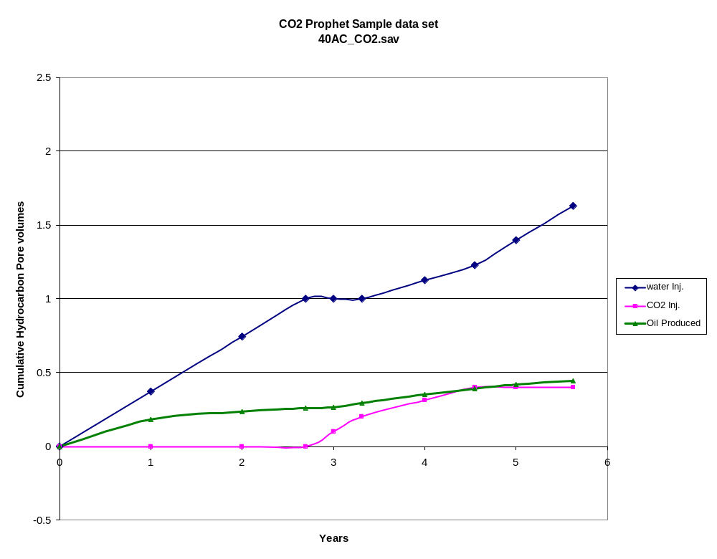
Figure 2. Sample 40-acre, 5-spot pattern CO₂ flood

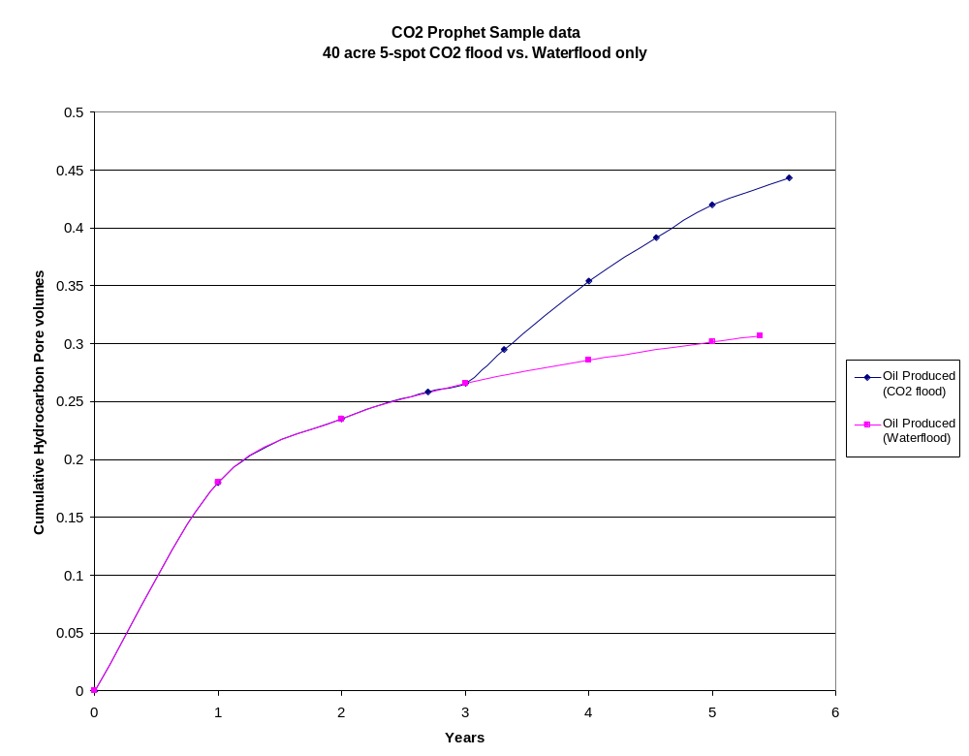
Figure 3. Comparison of waterflood vs. CO₂ flood for 40-acre, 5-spot pattern

Sensitivity Analysis:

Dykstra Parson’s Coefficient

A sensitivity analysis was performed in order to show the effect of Dykstra Parson’s coefficient of reservoir heterogeneity on cumulative oil production. The CO₂ flood test case 40AC_CO2.sav was run with four different values for Dykstra Parson’s coefficient, and cumulative production vs. time was plotted in Figure 4. Results show that increasing Dykstra Parson’s coefficient (increasing heterogeneity) results in lower oil production - everything else being the same.

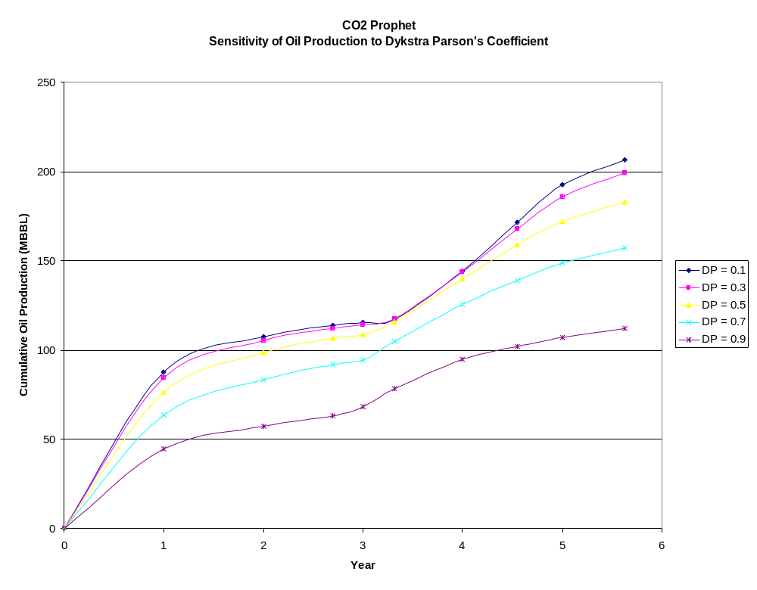
Figure 4. Sensitivity of CO₂ Prophet to Dykstra Parson’s coefficient

Oil Viscosity

A simple sensitivity analysis on the effects of oil viscosity on oil production was generated using the sample CO₂ flood test case 40AC_CO2.sav. The model was run using the default value of 2 cp, and then run three additional times with values of 1, 10, and 50 cp. Figure 5 shows that for the range of oil viscosities analyzed, oil production clearly decreases with increasing oil viscosity.
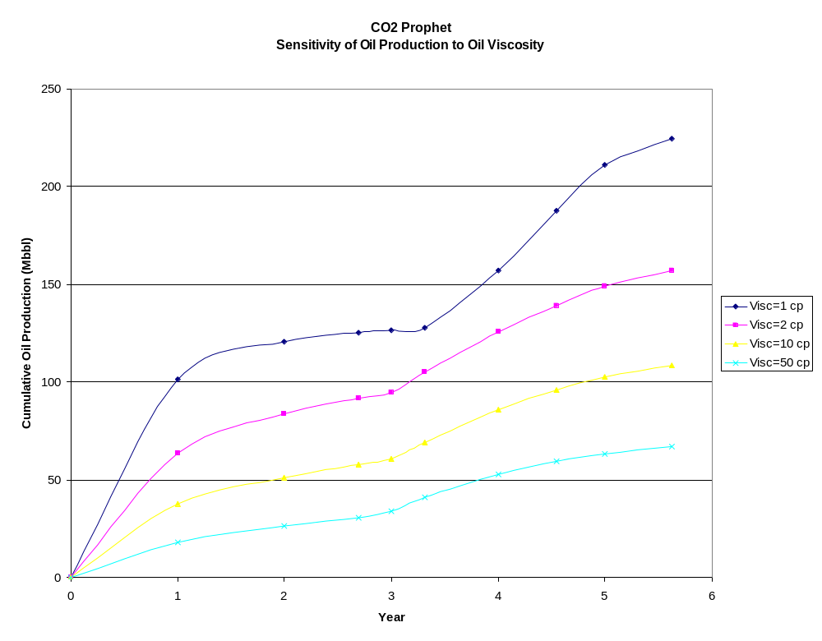
Figure 5. Sensitivity of oil production in CO₂ Prophet to oil viscosity

API Gravity

The CO₂ Prophet model was tested for sensitivity to API gravity. A range of different values of API gravity from 10 to 35 degrees were run using the CO₂ flood test case 40AC_CO2.sav. The model was shown to be totally insensitive to API gravity as far as oil production was concerned. A study of the code showed that API gravity is only used to calculate the density of the oil, which is reported in the model output but has no bearing on oil recovery in the model whatsoever.

Pattern Configuration

The next sensitivity analysis involved pattern configuration. The 40-acre, 5-spot CO₂ flood test case 40AC_CO2.sav was run an additional three times using three different pattern configurations. The three additional pattern configurations were line drive, 7-spot, and 9-spot. Results of this analysis are displayed in Figure 6. Assuming the same injection rates, etc., the 5-spot pattern maximizes production with line drive being second, 7-spot third, and 9-spot producing the least oil.

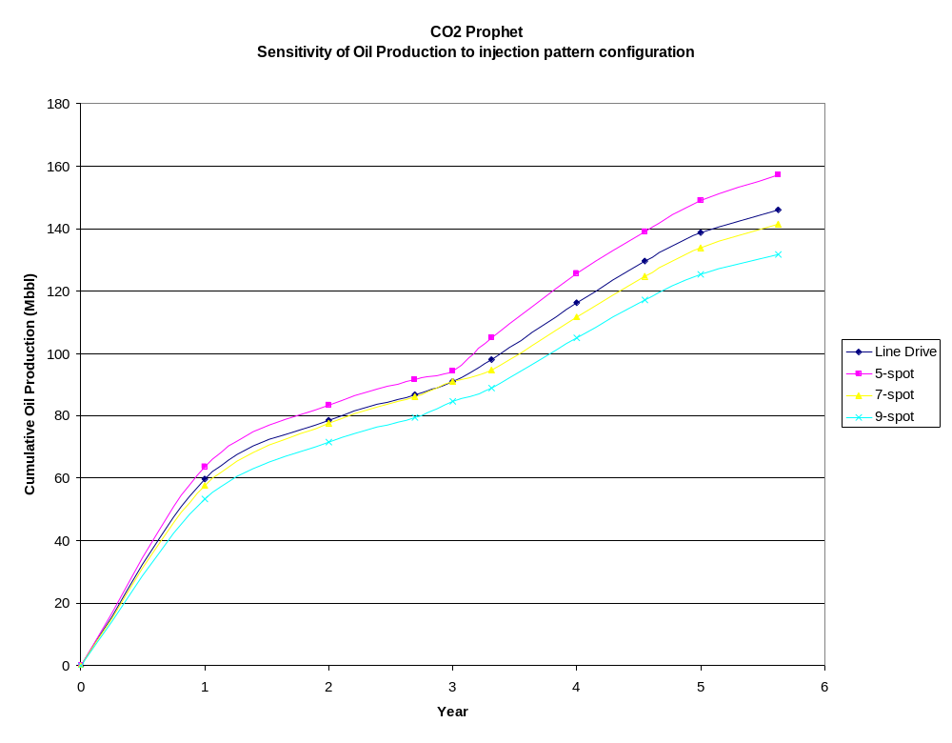
Figure 6. Sensitivity of oil production in CO₂ Prophet to pattern configuration

Reservoir Pressure

A final sensitivity was performed to analyze the effects of reservoir pressure on oil produced under the 40-acre, 5-spot test case 40AC_CO2.sav. Besides the default value of 2000 psi, the model was run assuming average reservoir pressures of 500, 1000, 1500, 2500, and 3000 psi. Aside from average reservoir pressure, all of the other variables remained the same in this set of runs. The minimum miscibility pressure was set at 1200 psi for all of the runs. This means that the runs at 500 and 1000 psi represent immiscible floods, while the remaining three runs are miscible. Since the 1000 psi run was less than the minimum miscibility pressure but greater than 75% of the minimum miscibility pressure, it has relative permeability properties which fall in between those of an immiscible and a miscible flood. Figure 7 shows the cumulative oil production under each of the 6 average reservoir pressures. Clearly the best production for this test case occurs at an average reservoir pressure of 2000 psi.

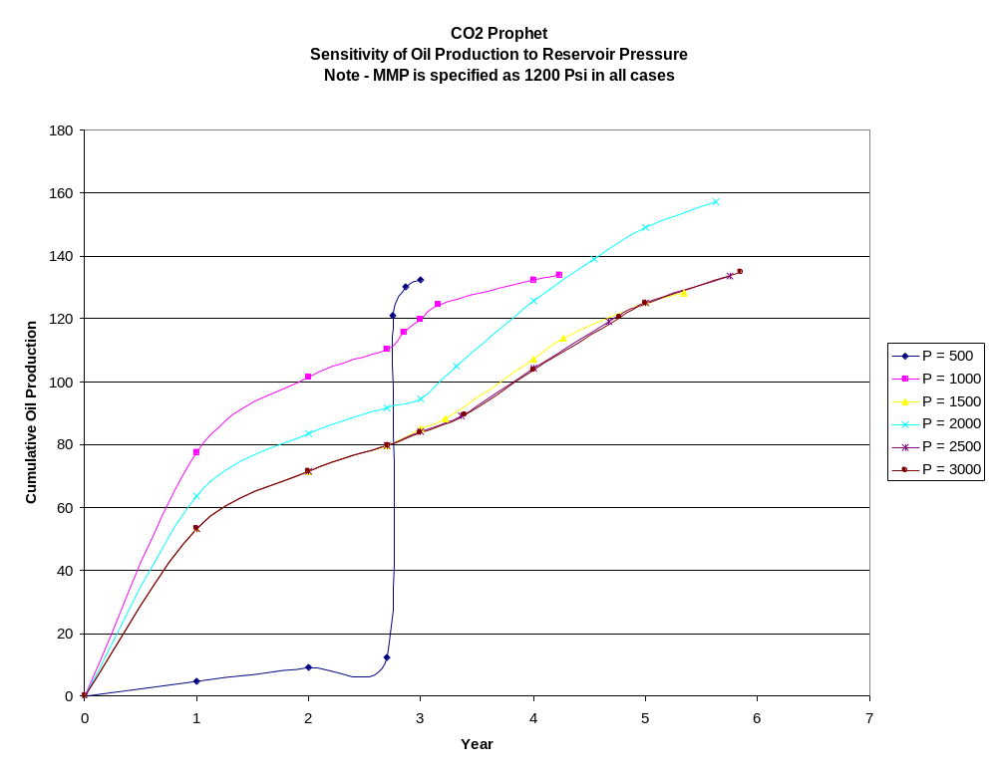
Figure 7. Sensitivity of oil production in CO₂ Prophet to average reservoir pressure

